**DIY Laser Printer Documentation**

By Koo Jin Chu BK2011

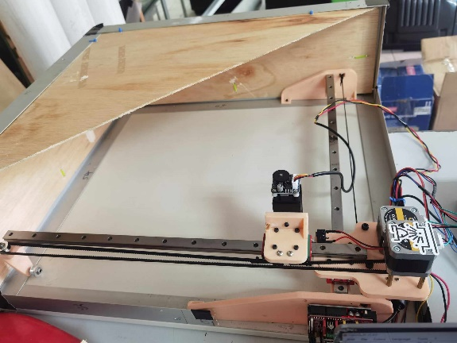

**Safety & Precaution:**

1. Do not leave machine running without monitoring
2. Make sure the environment is well ventilated
3. Wear Laser Safety Goggle to monitor while machine is running
4. Do not touch the linear bearing, it will rust.
5. Do not put flammable item near to the machine.

**Setup**

Software:

1. Download open-source CNC software (LaserGRBL). Link: <https://lasergrbl.com/download/>
2. After installation, go to Grbl -> grbl configuration ->import -> select gbrl config.nc -> write to machine (if first time). The configuration is done to suit the machine. Configuration parameter can be found in its website. Link: <https://lasergrbl.com/configuration/>
3. Go to Grbl -> setting-> set it as below ->save

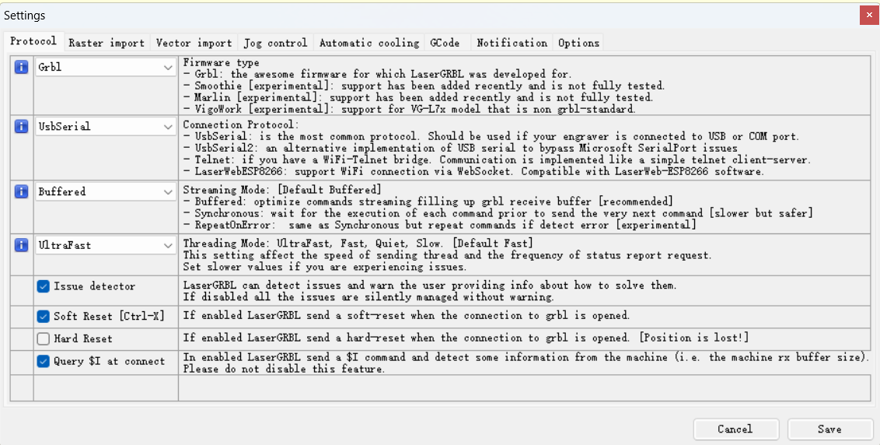

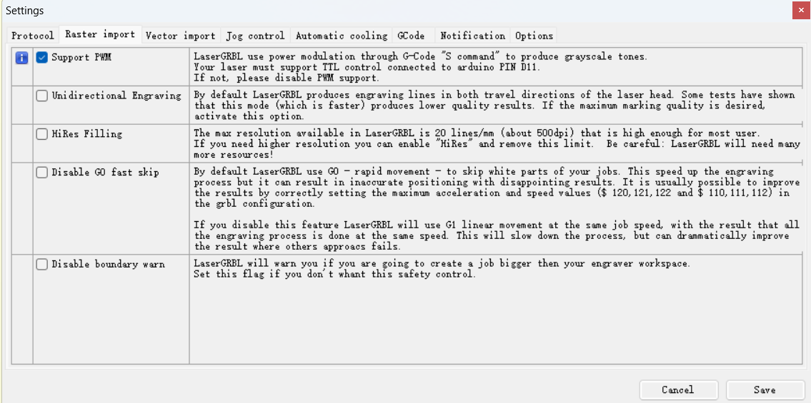

1. Familiar with User Interface. link: <https://lasergrbl.com/usage/user-interface/>

Hardware:

1. Adjusting the focal length of the laser module until a sharp point is present

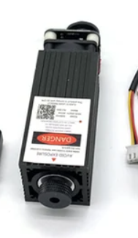



1. Adjusting the knob on top of the module to set the power of the laser module.

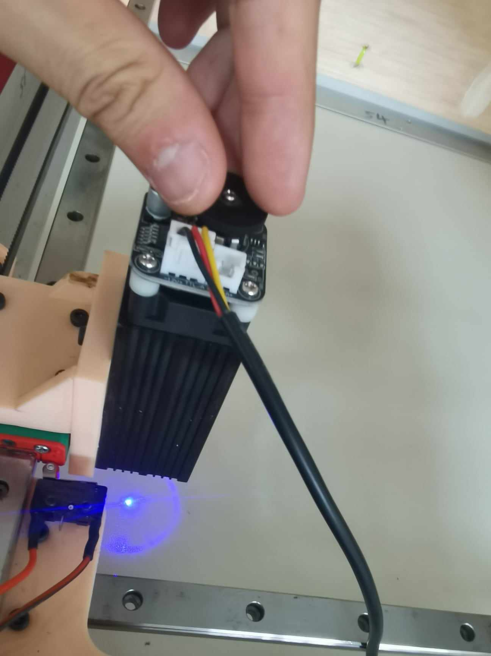

1. The stepper motor is rated at 1.4A max. The higher the current, the hotter the stepper motor is. It is necessary to tune the current limiter in the stepper motor driver module. It is encouraged to limit it below 1A.

How to tune: <https://lastminuteengineers.com/drv8825-stepper-motor-driver-arduino-tutorial/#:~:text=The%20DRV8825%20stepper%20motor%20driver,A%20output%20current%20per%20coil>.

**Quick Start**

1. Turn on power supply
2. Connect the USB from computer to machine
3. Choose the correct COM and select baud rate as 115200, then click connect

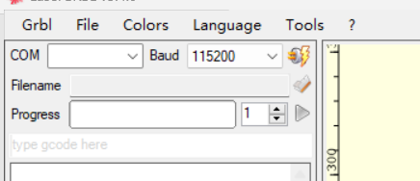

1. Once the machine is connected. The machine will be on locked state. Click ‘Grbl Unlock’ to unlock.

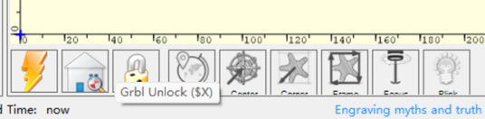

1. Once machine is unlocked, the machine will be able to control like homing, engraving and moving
2. It is a good practice to do homing the machine before engraving

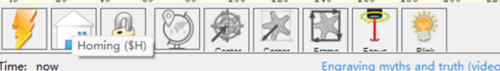

1. Choose file to print

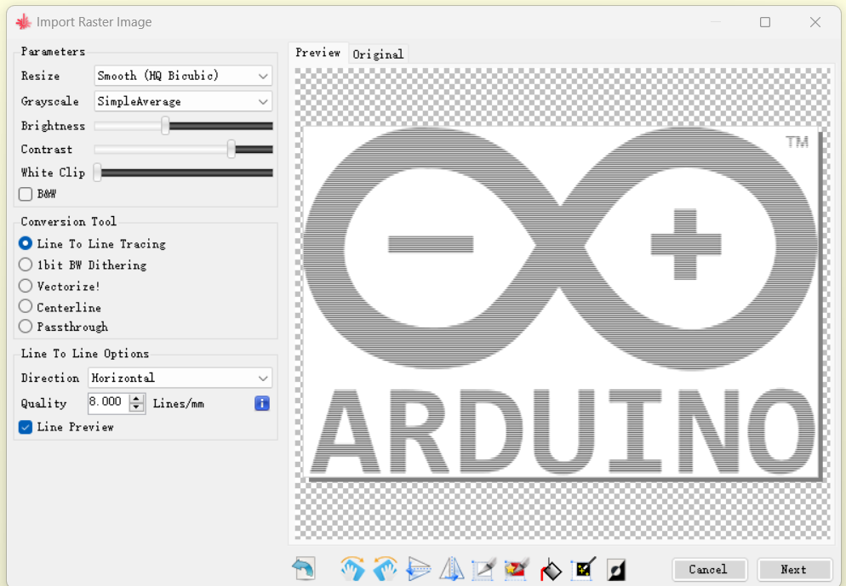

Image setting

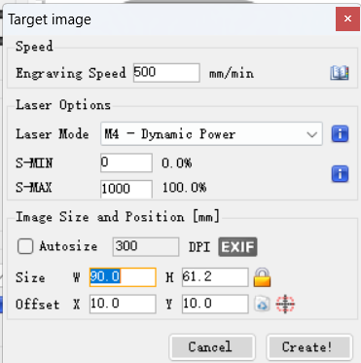

Machine setting

1. Click framing to locate the location of the image and load the material that need to be engraved
2. Start the engraving

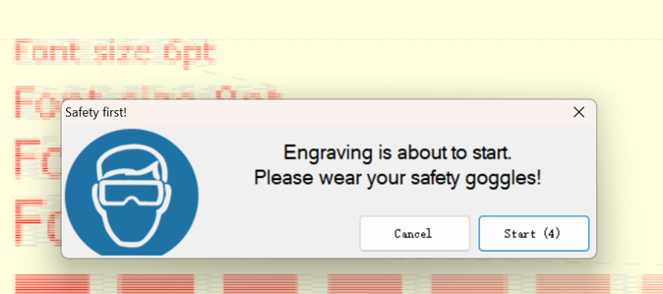

1. Wait until finish

Potential Problem:

1. The engraving power is too low.

Solution: Turn the knob on the laser module to adjust the power (Clockwise give higher power)

1. The machine stops suddenly.

Solution: Troubleshoot the problem, sometime can be disconnection between machine and computer. Click on start printing. It will give u a few option to choose: i) Start over, ii) Continue at where it stop and iii) continue at a few command before it stop.

**Reference:**

<https://howtomechatronics.com/projects/simplest-cnc-machine-with-minimum-parts-possible-diy-laser-engraver/>